**Lab 3**

**Scenario**

**Lemon Soda Service**

“Thela”, lemon soda offering company has decided to take orders online. Customer places the order online and at the time of delivery pays the bill. Order is prepared and delivered by the delivery man to the customer. Customer pays the bill to the delivery man.

Perform the following tasks on the given scenario:

* Identify Entities.
* Identify the attributes of the entities.
* Identify the relationships between the entities.
* Draw the Entity Relationship diagram from the information extracted in first three tasks.

**Solution:**

**ERD**

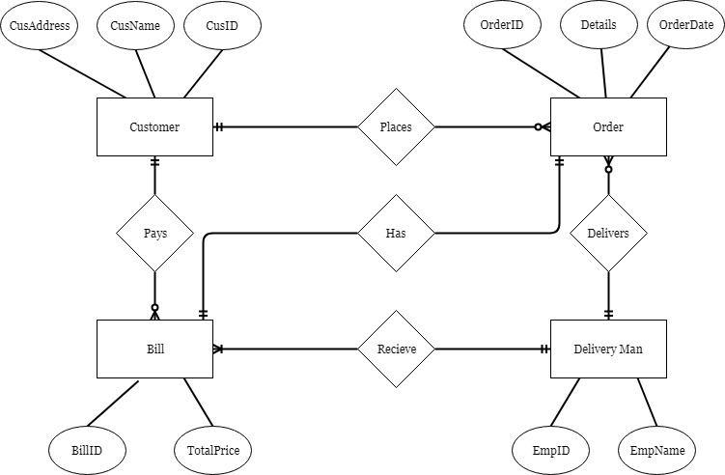

**Mechanism to Conduct Lab:** Lab will be conducted via Adobe Connect.